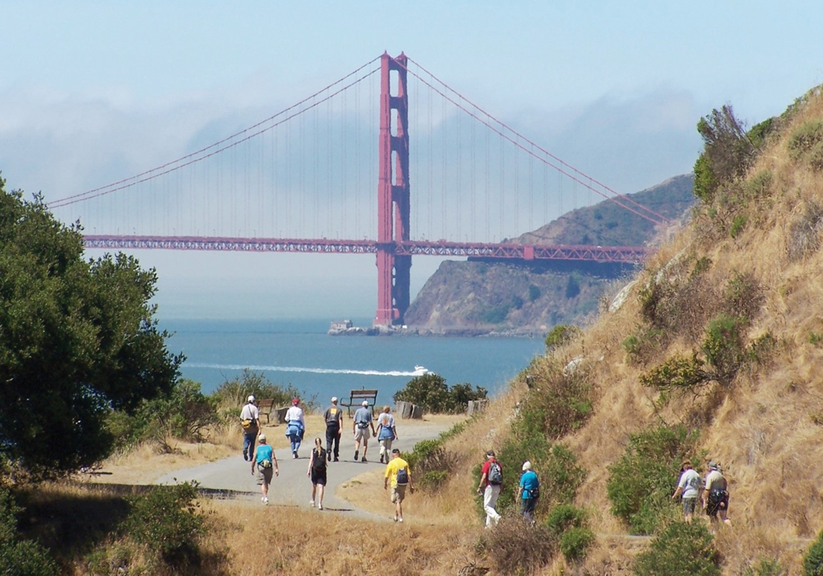

TO FIND A LIFE-CHANGING WALK NEAR YOU GO TO **AVA.ORG.**

**Event Name**

Event Location

Event Address

Event Date/Time

Event Contact

**Event Name**

Event Location

Event Address

Event Date/Time

Event Contact

**Event Name**

Event Location

Event Address

Event Date/Time

Event Contact

If you love to walk and meet new friends, join one of our events. Bring your family, friends and even the family dog on one of these unique trails.

**WALKING FOR FUN, FITNESS AND FRIENDSHIP.**

**CLUB NAME**